**IPC Problems Using Semaphore**

**1. Dining Philosophers Problem**

**Code:**

#include<sys/types.h>

#include<unistd.h>

#include<stdio.h>

#include<sys/wait.h>

#include<sys/sem.h>

#include<sys/ipc.h>

#include<sys/shm.h>

#define EATING 0

#define HUNGRY 1

#define THINKING 2

#define KEY 123

union semun {

int val;

struct semid_ds *buf;

unsigned short *array;

};

struct sembuf p = { 0, -1, SEM_UNDO}; // WAIT

struct sembuf v = { 0, +1, SEM_UNDO}; // SIGNAL

struct smph

{

int State[5];

};

void Initialize(struct smph * SHM )

{

for(int i=0;i<5;i++)

{

SHM->State[i]=THINKING;

}

}

void test(int i, struct smph * SHM, int semid)

{

if(SHM->State[i]==HUNGRY&&SHM->State[(i+1)%5]!=EATING&&SHM->State[(i+4)%5]!=EATING)

{

v.sem_num=i;

semop(semid,&v,1);

//sem_post(&S[i]);

}

}

void Pickup(int i,struct smph * shm, int semid)

{

p.sem_num=5;

semop(semid,&p,1);

//sem_wait(&mutex);

shm->State[i]=HUNGRY;

printf("Philosopher %d is hungry\n", i);

sleep(1);

test(i,shm,semid);

v.sem_num=5;

semop(semid,&v,1);

//sem_post(&mutex);

p.sem_num=i;

semop(semid,&p,1);

//sem_wait(&S[i]);

}

void PutDown(int i, struct smph * shm, int semid)

{

//sem_wait(&mutex);

p.sem_num=5;

semop(semid,&p,1);

shm->State[i]=THINKING;

test((i+1)%5, shm, semid);

test((i+4)%5, shm, semid);

v.sem_num=5;

semop(semid,&v,1);

//sem_post(&mutex);

}

void Philosopher(int i, struct smph * shm, int semid)

{

while(1)

{

printf("Philosopher %d is thinking\n",i);

sleep(2);

Pickup(i,shm,semid);

shm->State[i]=EATING;

printf("Philosopher %d is eating \n",i);

sleep(2);

PutDown(i,shm,semid);

}

}

int main()

{

int shmid,semid,key;

struct smph * shm;

shmid=shmget(key,sizeof(struct smph),IPC_CREAT|0660);

if(shmid == -1)

perror("Shared Memory fault\n");

shm= (struct smph *)shmat(shmid, NULL, 0);

if(shm == (void *) - 1)

perror("Attachment fault\n");

Initialize(shm);

union semun u;

semid = semget(KEY, 6, 0666 | IPC_CREAT);

u.val = 0;

for(int i=0;i<5;i++)

{

semctl(semid, i, SETVAL, u);

}

u.val = 1;

semctl(semid, 5, SETVAL, u);

for(int i=0;i<5;i++)

{

if(fork() == 0)

{

shm = (struct smph *)shmat(shmid, NULL, 0);

Philosopher(i, shm, semid);

break;

}

}

wait(NULL);

}

**Output:**

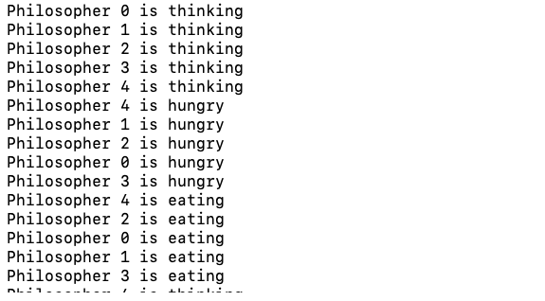

**2. Producer Consumer Problem**

**Code:**

#include<unistd.h>

#include<stdio.h>

#include<sys/types.h>

#include<sys/ipc.h>

#include<sys/shm.h>

#include<stdlib.h>

#include<sys/wait.h>

#include<sys/sem.h>

#define KEY 123

#define N 10

union semun {

int val;

struct semid_ds *buf;

unsigned short *array;

};

struct sembuf p = { 0, -1, SEM_UNDO}; // WAIT

struct sembuf v = { 0, +1, SEM_UNDO}; // SIGNAL

struct smph

{

int Array[10];

int in;

int out;

};

void Producers(int semid, struct smph * shm)

{

int item=rand()%100;

p.sem_num=0;

semop(semid,&p,1);

p.sem_num=2;

semop(semid,&p,1);

shm->Array[shm->in]=item;

printf("Producing item : %d \n",item);

shm->in=(shm->in+1)%N;

v.sem_num=2;

semop(semid,&v,1);

v.sem_num=1;

semop(semid,&v,1);

}

void Consumers(int semid, struct smph * shm)

{

int item;

p.sem_num=1;

semop(semid,&p,1); // Wait for empty

p.sem_num=2;

semop(semid,&p,1);

item=shm->Array[shm->out];

shm->out=(shm->out+1)%N;

printf("Consuming item : %d \n",item);

v.sem_num=2;

semop(semid,&v,1); // Signal for full

v.sem_num=0;

semop(semid,&v,1);

}

int main()

{

int shmid,semid,key;

struct smph * shm;

shmid=shmget(key,sizeof(struct smph),IPC_CREAT|0660);

if(shmid==-1)

perror("Shared Memory fault\n");

shm=shmat(shmid,NULL,0);

if(shm== (void *) -1)

perror("Attachment fault\n");

shm->in=0;

shm->out=0;

union semun u;

u.val = N;

semid = semget(KEY, 3, 0666 | IPC_CREAT);

semctl(semid, 0, SETVAL, u);

u.val=0;

semctl(semid,1,SETVAL,u);

u.val=1;

semctl(semid,2,SETVAL,u);

int pid=fork();

if(pid==0)

{

shm=shmat(shmid,NULL,0);

while(1)

Producers(semid,shm);

}

else

{

//shm=shmat(shmid,NULL,0);

while(1)

Consumers(semid,shm);

}

return 0;

}

**Output:**

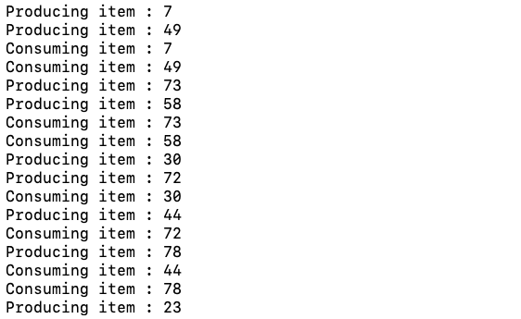

**3. Readers Writers Problem**

**Code:**

#include<stdio.h>

#include<sys/types.h>

#include<sys/wait.h>

#include<pthread.h>

#include<stdlib.h>

#include<unistd.h>

#include<sys/sem.h>

#include<sys/ipc.h>

#include<sys/shm.h>

#define KEY 123

union semun {

int val;

struct semid_ds *buf;

unsigned short *array;

};

struct sembuf p = { 0, -1, SEM_UNDO}; // WAIT

struct sembuf v = { 0, +1, SEM_UNDO}; // SIGNAL

struct smph

{

int readercount;

};

void reader(int semid, struct smph * shm)

{

printf("Attempting to read\n");

p.sem_num=0;

semop(semid,&p,1);

shm->readercount++;

if(shm->readercount==1)

{

p.sem_num=1;

semop(semid,&p,1);

}

int q=rand()%5;

printf("Reading\n");

v.sem_num=0;

semop(semid,&v,1);

sleep(q);

p.sem_num=0;

semop(semid,&p,1);

shm->readercount--;

if(shm->readercount==0)

{

v.sem_num=1;

semop(semid,&v,1);

}

v.sem_num=0;

semop(semid,&v,1);

}

void writer(int semid, struct smph * shm)

{

int q=rand()%3;

printf("Atempting to write\n");

p.sem_num=1;

semop(semid,&p,1);

printf("Writing \n");

sleep(q);

v.sem_num=1;

semop(semid,&v,1);

}

int main()

{

struct smph *shm;

int shmid,semid,key,i;

shmid=shmget(key,sizeof(struct smph),IPC_CREAT|0660);

if(shmid==-1)

perror("Shared Memory fault\n");

shm=shmat(shmid,NULL,0);

if(shm== (void *) -1)

perror("Attachment fault\n");

shm->readercount=0;

union semun u;

semid = semget(KEY, 2, 0666 | IPC_CREAT);

u.val=1;

semctl(semid, 0, SETVAL, u); // Lock

semctl(semid,1,SETVAL,u); // Write LOck

for(i=0;i<15;i++)

{

int pid=fork();

if(pid==0&&(i%2)==0)

{

shm= (struct smph *) shmat(shmid,NULL,0);

reader(semid,shm);

break;

}

else if(pid==0&&(i%2)==1)

{

shm= (struct smph *) shmat(shmid,NULL,0);

writer(semid,shm);

break;

}

}

while(2)

{

int r=wait(NULL);

if(r<0)

break;

}

return 0;

}

**Output:**

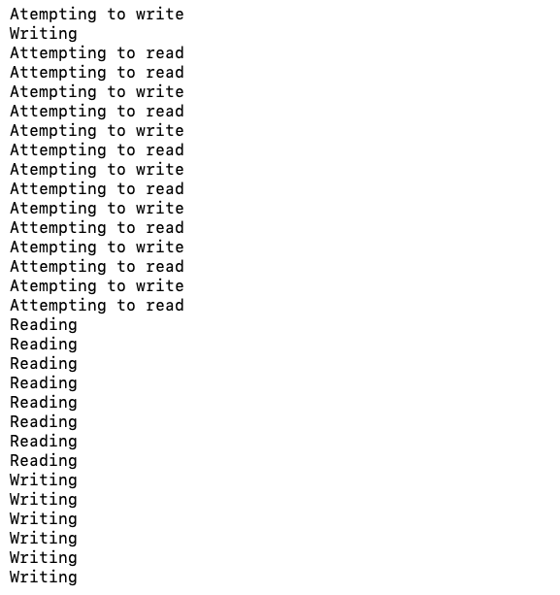

1. **Sleeping Barber Problem**

**Code:**

#include<stdio.h>

#include<sys/types.h>

#include<sys/ipc.h>

#include<sys/sem.h>

#include<semaphore.h>

#include<sys/wait.h>

#include<pthread.h>

#define MAXCHAIRS 5

#include<unistd.h>

#include<sys/shm.h>

#include<stdlib.h>

#define CUSTOMER 1

#define BARBER 0

#define DONECUTTING 2

#define LOCK 3

#define KEY 123

struct smph

{

int nowaiting;

};

// Customer 0

// Barber 1

// Done cutting 2

union semun {

int val;

struct semid_ds *buf;

unsigned short *array;

};

void Post(int semid, int sid)

{

struct sembuf v = { 0, +1,0}; // SIGNAL

v.sem_num=sid;

semop(semid,&v,1);

}

void Wait(int semid, int sid)

{

struct sembuf p = { 0, -1,0}; // WAIT

p.sem_num=sid;

semop(semid,&p,1);

}

void Barber(int semid, struct smph * shm)

{

while(1)

{

Wait(semid,CUSTOMER);

printf("Barber allocated\n");

Post(semid,BARBER);

printf("Barber is cutting hair\n");

sleep(2);

Post(semid, DONECUTTING);

Wait(semid, LOCK);

shm->nowaiting--;

Post(semid,LOCK);

}

}

void Customer(int semid, struct smph * shm)

{

Wait(semid,LOCK);

if(shm->nowaiting<MAXCHAIRS)

{

shm->nowaiting++;

printf("Customer Sitting\n");

Post(semid,LOCK);

Post(semid,CUSTOMER);

Wait(semid,BARBER);

Wait(semid,DONECUTTING);

printf("Customer exiting after getting service \n");

}

else

{

printf("Customer Left\n");

Post(semid,LOCK);

}

}

int main()

{

int shmid,semid,key,i;

struct smph * shm;

shmid=shmget(key,sizeof(struct smph),IPC_CREAT|0660);

if(shmid==-1)

perror("Shared Memory fault\n");

shm= (struct smph *)shmat(shmid,NULL,0);

if(shm== (void *) -1)

perror("Attachment fault\n");

shm->nowaiting=0;

union semun u;

semid = semget(KEY, 4, 0660 | IPC_CREAT);

u.val=0;

for(int i=0;i<3;i++)

{

semctl(semid, i, SETVAL, u);

}

u.val=1;

semctl(semid,3,SETVAL,u);

for(i=0;i<20;i++)

{

int pid=fork();

if(pid==0&&i==0)

{

//semid = semget(KEY, 4, 0666 | IPC_CREAT);

shm= (struct smph *)shmat(shmid,NULL,0);

Barber(semid, shm);

exit(0);

}

else if(pid==0&&i!=0)

{

//semid = semget(KEY, 4, 0666 | IPC_CREAT);

shm= (struct smph *)shmat(shmid,NULL,0);

Customer(semid, shm);

exit(0);

}

}

while(1)

{

int y=wait(NULL);

if(y<0)

break;

}

}

**Output:**

